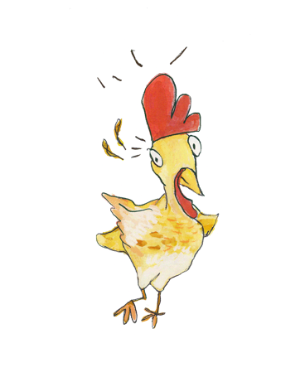
FLOUR SACK GIRL
STORY HOUR KIT

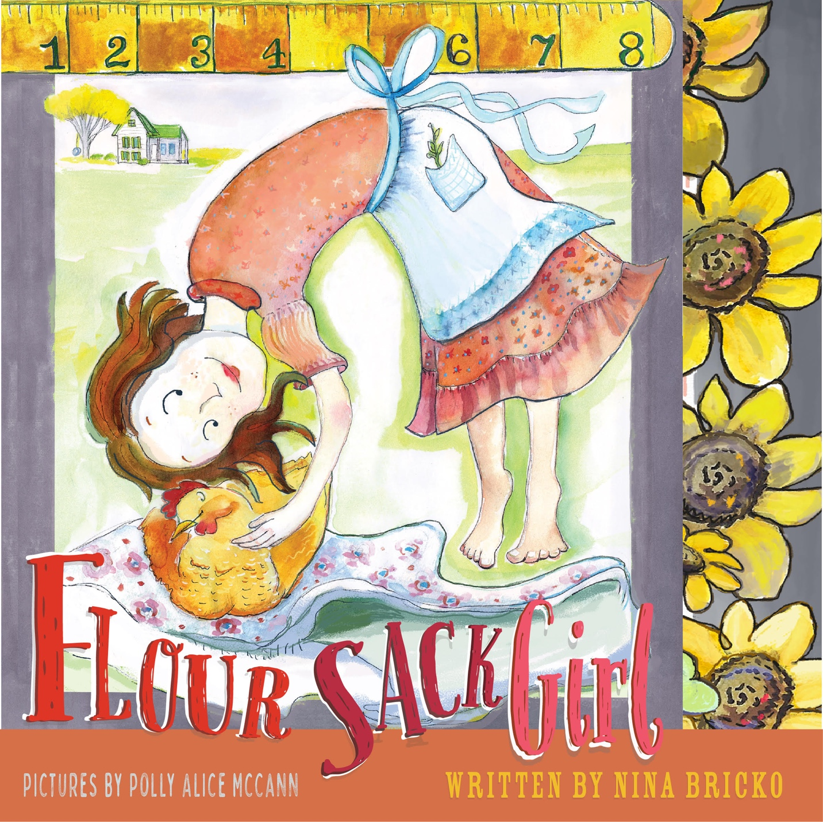

ABOUT THE KIT

This kit was designed for anyone hosting a read aloud or looking for ways to engage with the book.

Best for ages 3-8.
“Flour Sack Girl, by Nina Bricko, tells the story of how flour sacks were sewn into dresses during the depression, using her grandmother, Veleta Mae, as the plucky main character. The adept narrative is layered with themes of friendship, family, resilience, and ingenuity, while the poetic language employs a range of unique and witty similes that will have readers chuckling.”
—Lisa Jahn-Clough ALICIA HAS A BAD DAY (HarperCollins)
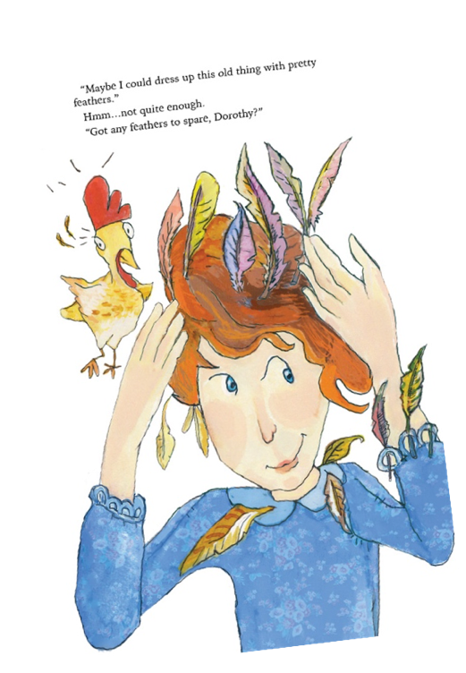
With this kit, your readers can recreate Veleta’s moment of ingenuity by making their own dress for a paper doll Veleta. Your readers may also like to make depression era bread or learn more about flour sack clothes.
An opportunity to learn about US history when times were tough, and that it took creativity and resilience to sometimes get what we needed. During the Great Depression, people made clothes from flour sack cloth that had been made with that purpose in mind. In this story, the reader sees Veleta try to solve a problem; her dress is thinner than paper and holier than Swiss cheese, so it just won’t do for her first day of school, but as she wonders the farm, she just can’t seem to come up with a solution. That is until Mama pulls out some delicious bread from the oven and Veleta spies the empty flour sack.

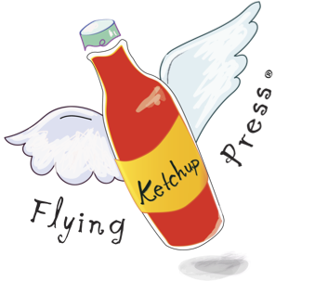
The kit contains:
— Poster and copy to share your event
— Suggested preparation
— Veleta Paper Doll Cut-out
— Depression Era Bread recipe
— Images of the era to show examples of flour sack fabric

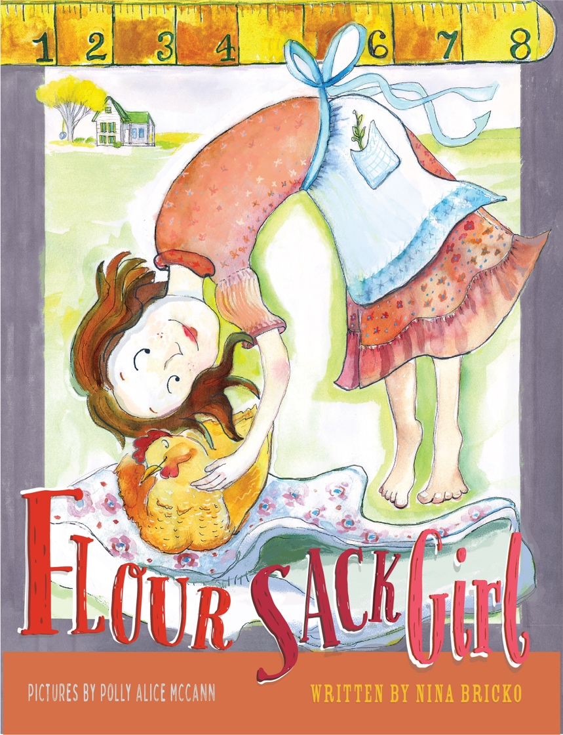
ABOUT THE BOOK FLOUR SACK GIRL

By Nina Bricko
Illustrated by Polly Alice mcCann
ISBN-13: 978-1-970151-49-7
Published by Flying Ketchup Kids / Flying Ketchup Press
Age Range: 3 - 8
Summary: During the Great Depression, a determined young girl has a Make-Do-Can-Do attitude. With a little help from Momma, Veleta Mae finds the perfect dress for school in an unexpected way–a flour sack.
Veleta Mae is 3 feet 9 inches tall with arms for climbing and toes that walk from end to end of her farm. When she learns that school starts soon, she slumps like a sack of potatoes on her kitchen floor. Her dress is thinner than paper, with a hole in her pocket that drops green beans like it was made of Swiss cheese. With an encouraging smile from her Momma, Veleta doesn’t give up hope. She begins her search to fix her dress. Maybe feathers will work? They look awfully nice on her fluffy chicken, Dorothy. Hmmm...Maybe flowers? Curtains? A tablecloth? Veleta Mae all but gives up when she spots an empty flour sack. Will it make the perfect dress?

PRAISE FOR THE BOOK
“Brimming with folksy language, Flour Sack Girl connects readers to a poignant, resilient time in US history when “making do” was by necessity a national pastime -- and a point of national pride.

Inspired by true events, readers will feel Veleta’s worry about attending school in a dress as thin as paper, one with pockets that can’t even hold beans. Rendered in clear colors, the energetic art and text are a lively match.

The author’s end-notes, the real Veleta photo, and two activities inspired by the story will engage and encourage curious readers.” —Miriam Busch LION, LION (Balzer + Bray)

"A story of pluck, spunk and invention in the face of
adversity. Nina Bricko delights with a good old-
fashioned tale of thinking outside the flour sack. The
lively text and playful illustrations will appeal to any
kid who's had to get creative to realize their
dreams."
—Peter Pearson HOW TO EAT AN AIRPLANE (HarperCollins)

ABOUT THE AUTHOR & ILLUSTRATOR
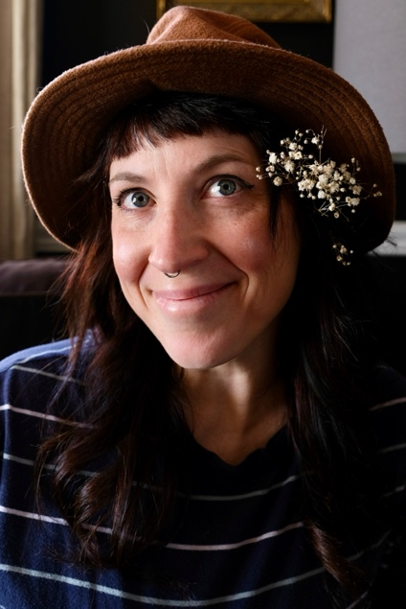
Voice artist and storyteller Nina Bricko has an MFA in Creative Writing for Children through YA. An avid DIY’er, Nina enjoys making things from nothing and taking her two kids on nature adventures. Nina is the voice of Saturday Morning Projects, Season 2, on the streaming channel “At Home with the Family Handyman.” She also produces and narrates picture books for Flying Ketchup Press. Find out more about her audiobooks, author visits, and projects at NinaBricko.com.

PREPARING FOR THE ACTIVITIES

You can, of course, create your own program, but in case you need some inspiration, the following are some suggestions to prepare for an event or classroom experience.

___ Locate a copy of the picture book FLOUR SACK GIRL by Nina Bricko
___ Print the Paper Doll on card stock paper. Print enough so that each reader can have a Paper Doll.

SHARING THE EVENT
___ There are some social media images in the packet that you can use to promote the event.
___ If you list your events in newsletters and/or online calendars, here is some text that may help with those listings:

Meet a determined young girl from the 1930s who has a Make-Do-Can-Do attitude. Veleta Mae finally gets to go to school, but her dress is thinner than paper, with pockets holier than Swiss cheese. She searches her family’s farm for inspiration on what to wear. With a little help from Momma and her pet chicken, Dorothy, Veleta finds the perfect dress in an unexpected way–a flour sack. Come be inspired by Veleta and learn about the little-known history of making clothes from flour sacks! We’ll be reading the picture book FLOUR SACK GIRL by Nina Bricko (Flying Ketchup Kids) and making a new dress for your very own paper doll. All welcome, but best for ages 3-8.

___ If this event is for the public, print out the event poster, add your date, time, and location, and duplicate it to advertise the event.

DAY OF THE EVENT
___ On your craft table, lay out colored paper, fabric, buttons, dried flowers, feathers or any other materials that kids might be inspired to use for decorating a dress, glue, tape, and crayons or markers, and scissors.
___ On your craft table, lay out the paper doll—one per kid and the dress template to trace.
___ Read aloud the picture book FLOUR SACK GIRL
___ Invite readers to talk about the story by revisiting spreads from the book. You can add dialogue like: [Showing the first page] What do you think Veleta is feeling when she discovered she finally got to school?

[Showing page 20] Momma said “Now you’ve got it.” And then winked. Do you think Momma had this in mind? But wanted Veleta to think of it herself?

{Showing page 27] The text says “Do you have a flour sack?” What is Veleta going to do to help Ellie?

[Showing the final] Can you see their clothes; they all have patterns—they must be wearing flour sack clothes too!

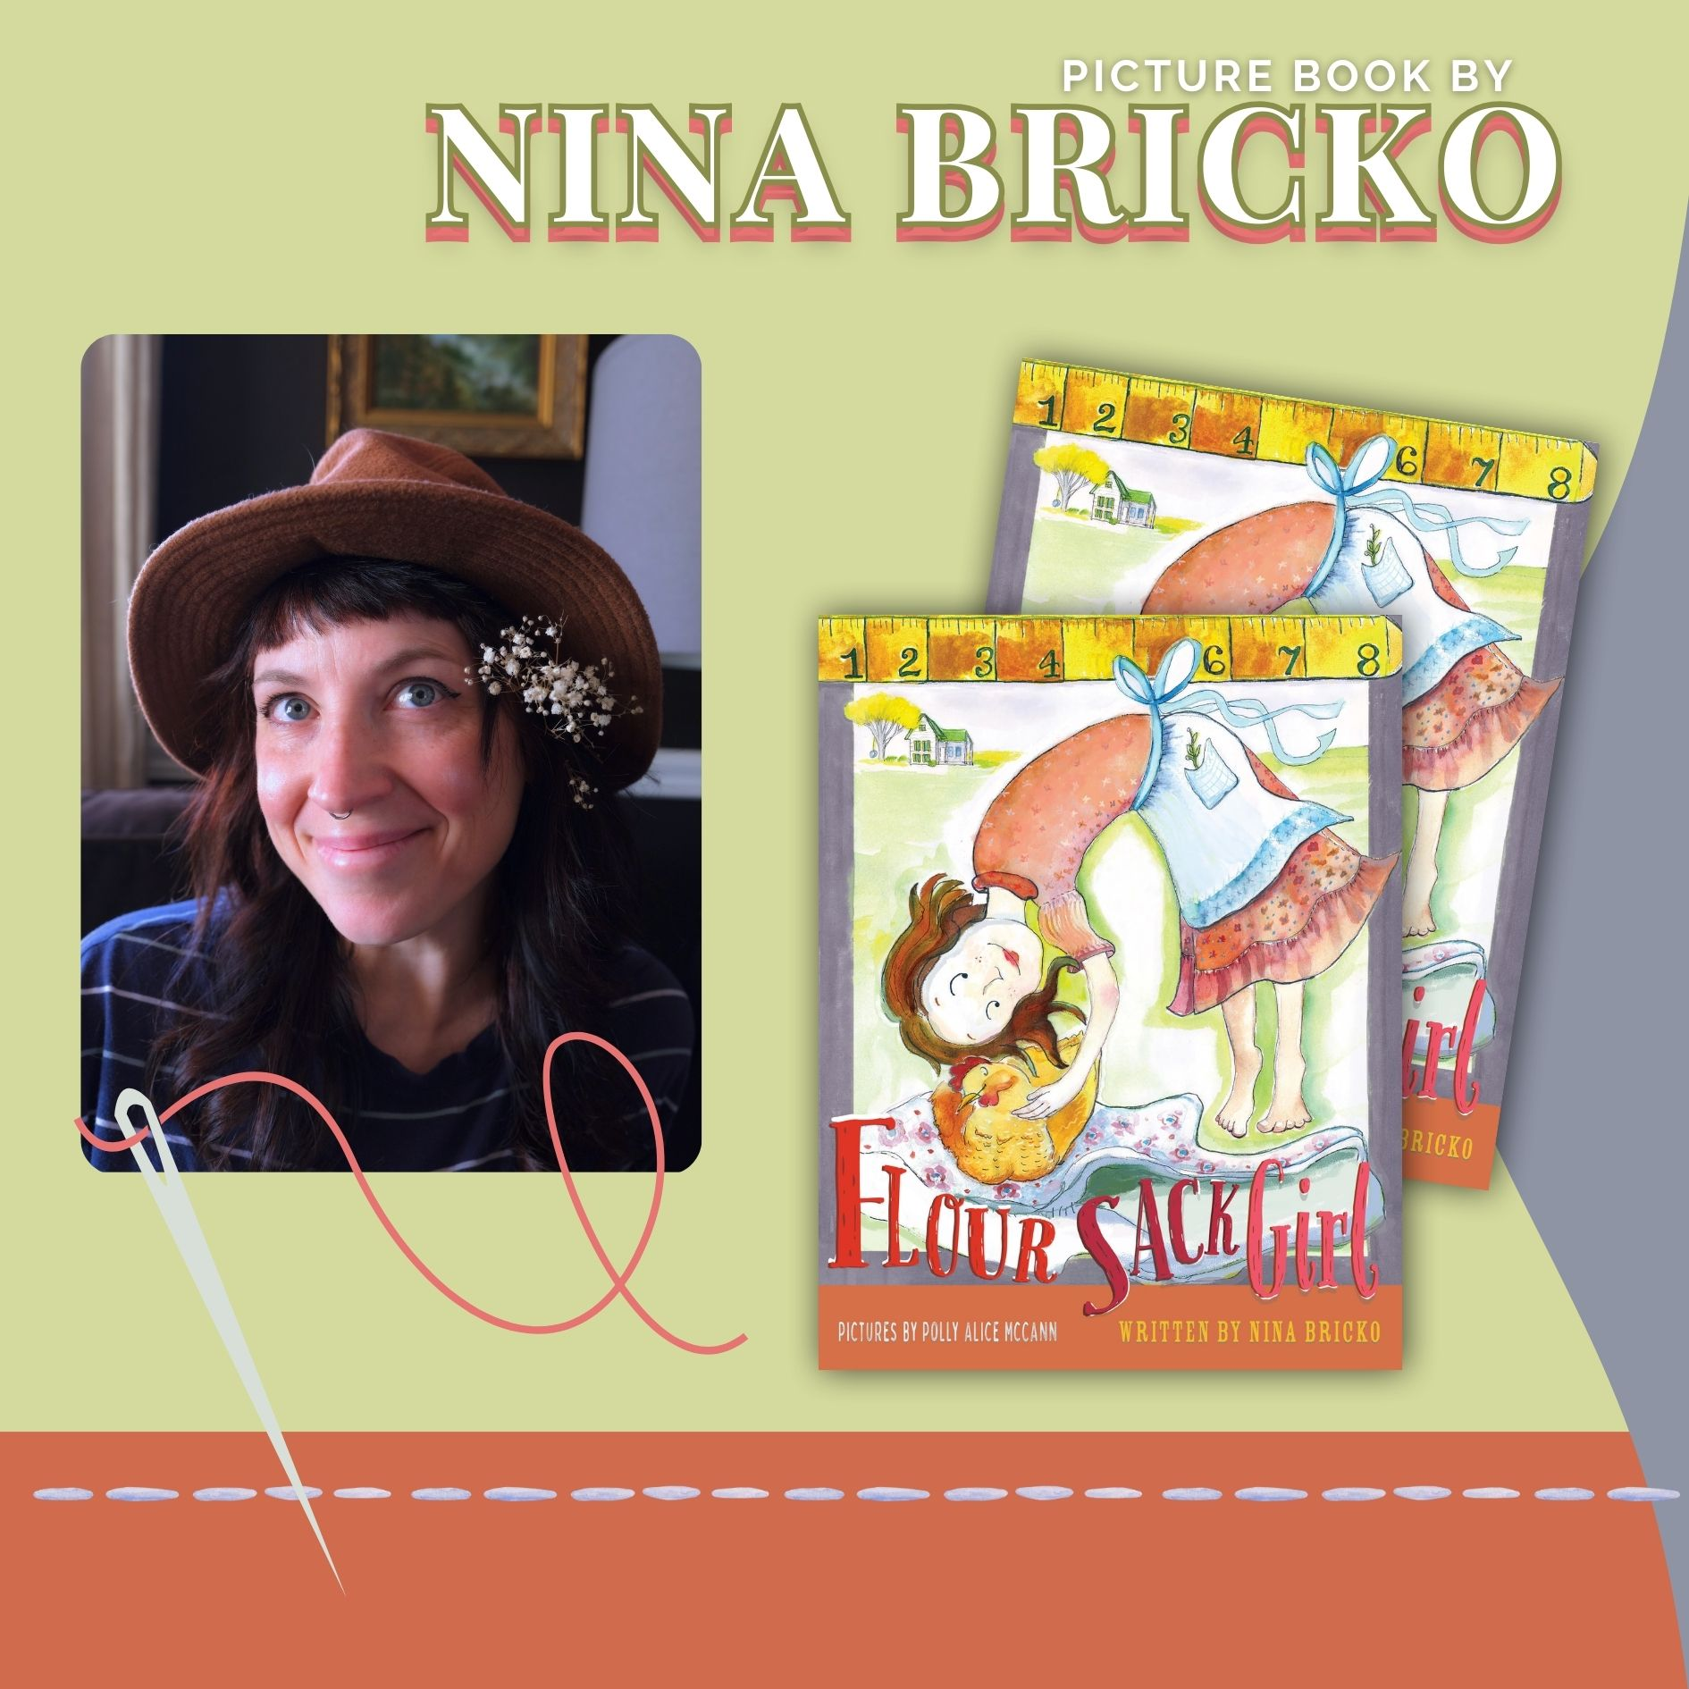
Social Media images:
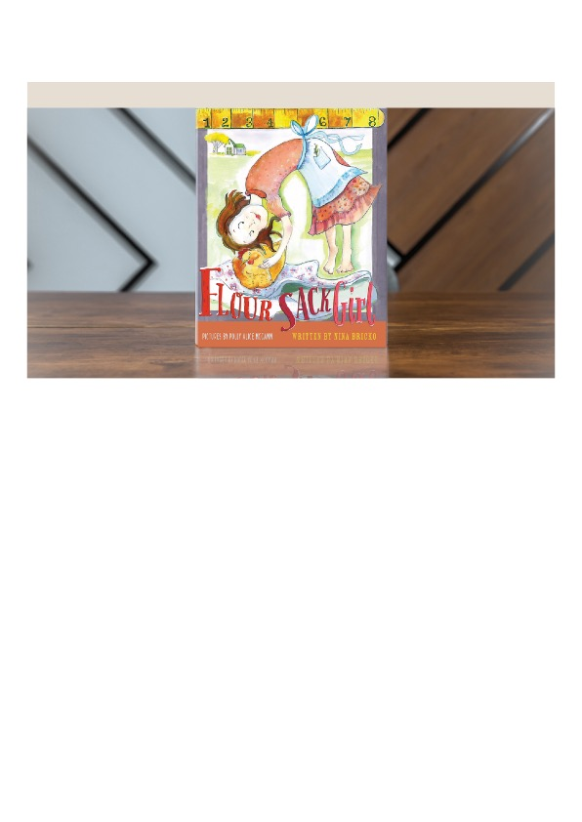
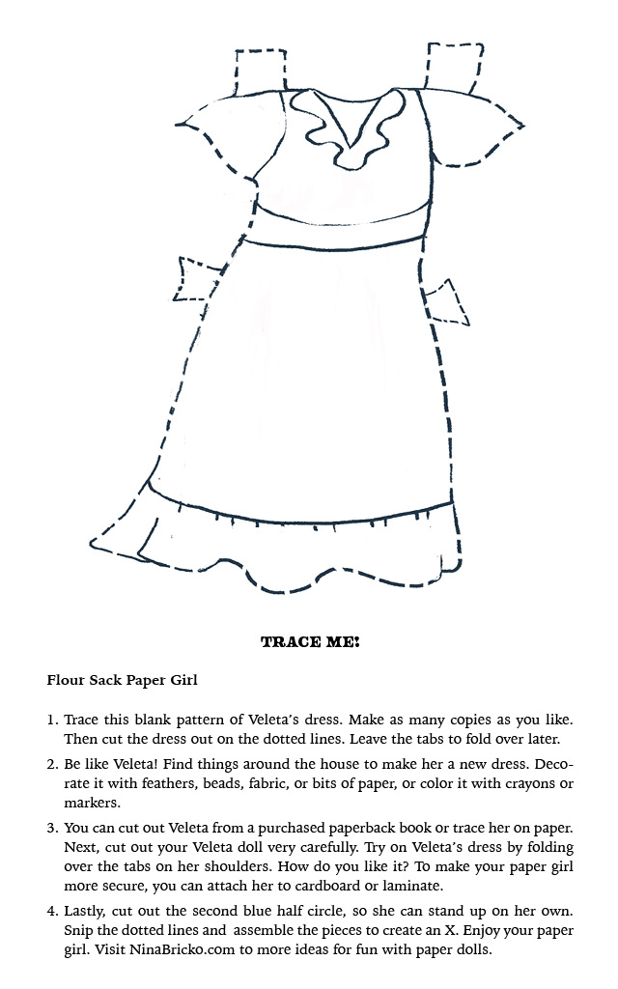

Have students design their own clothes for Veleta. Print the paper doll Veleta on card stock.
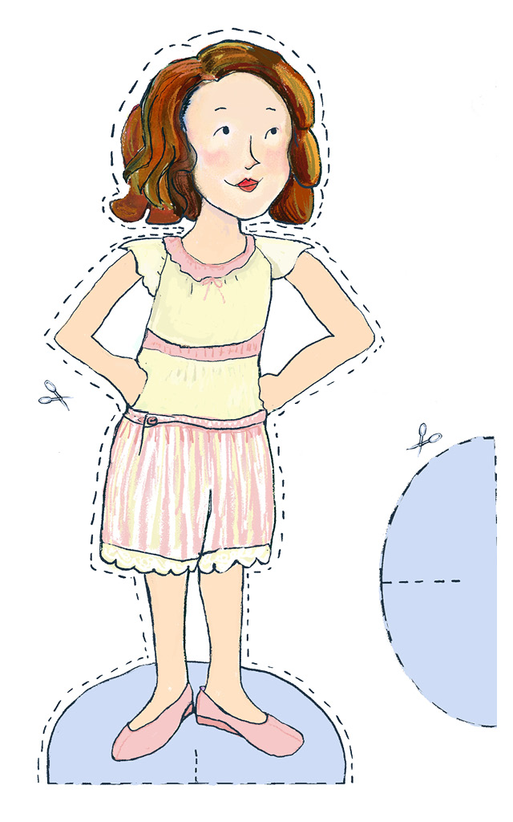

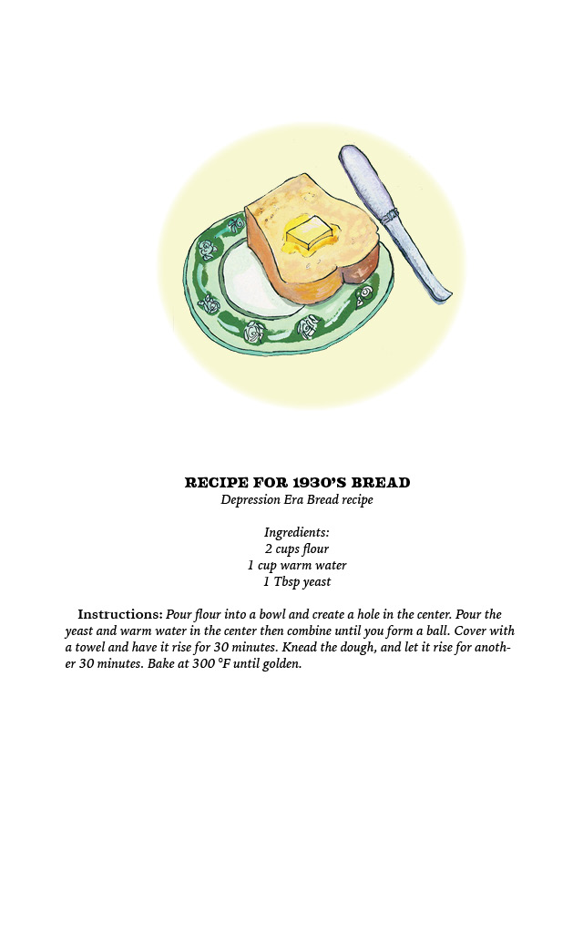

Images from history:

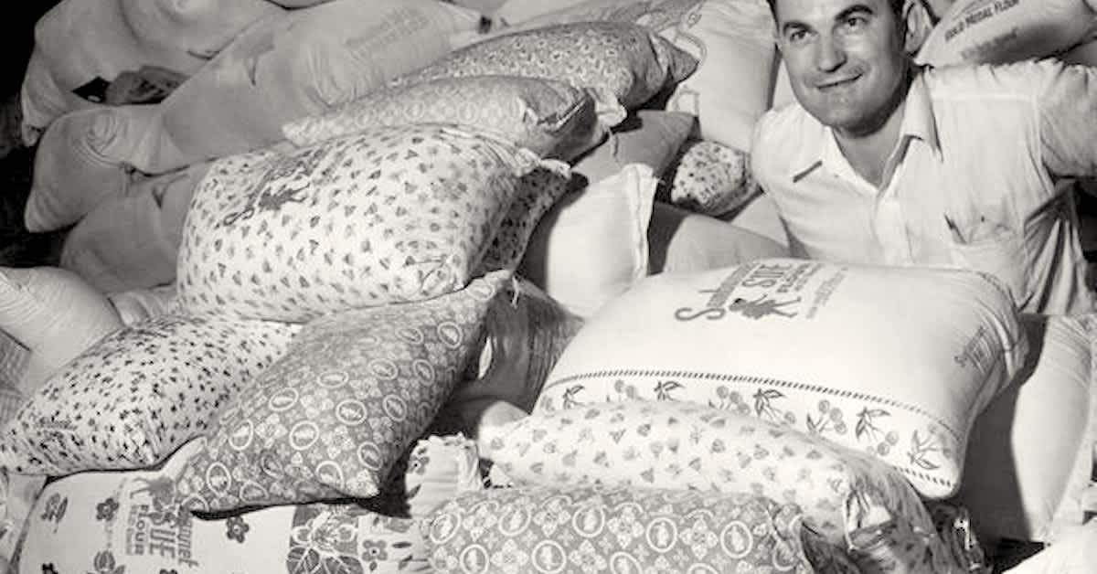
Flour sacks with decorative fabric

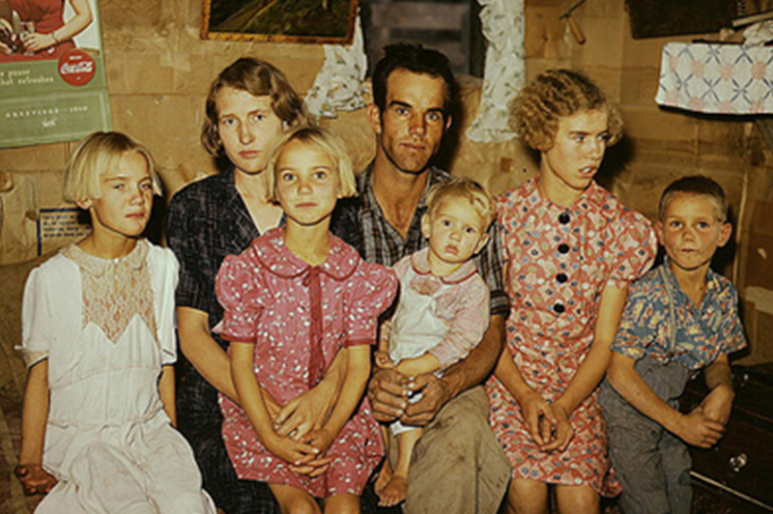
Flour sack clothes

